**FULL SUBTRACTOR**

**AIM:**

To design and implement the full subtractor using Logisim simulator.

**PROCEDURE:**

1. Pick and place the necessary gates.
2. Insert 3 inputs into the canvas.
3. Connect the inputs to the XOR gate, AND gate and OR gate.
4. Insert 2 outputs into the canvas.
5. Make the connections using the connecting wires.
6. Verify the truth table.

**TRUTH TABLE:**

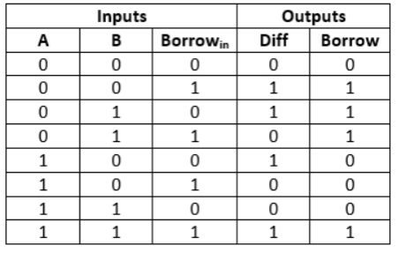

Diff=(A ⊕ B) ⊕ 'Borrowin'

Borrow=A'.B + (A ⊕ B)'

**OUTPUT**

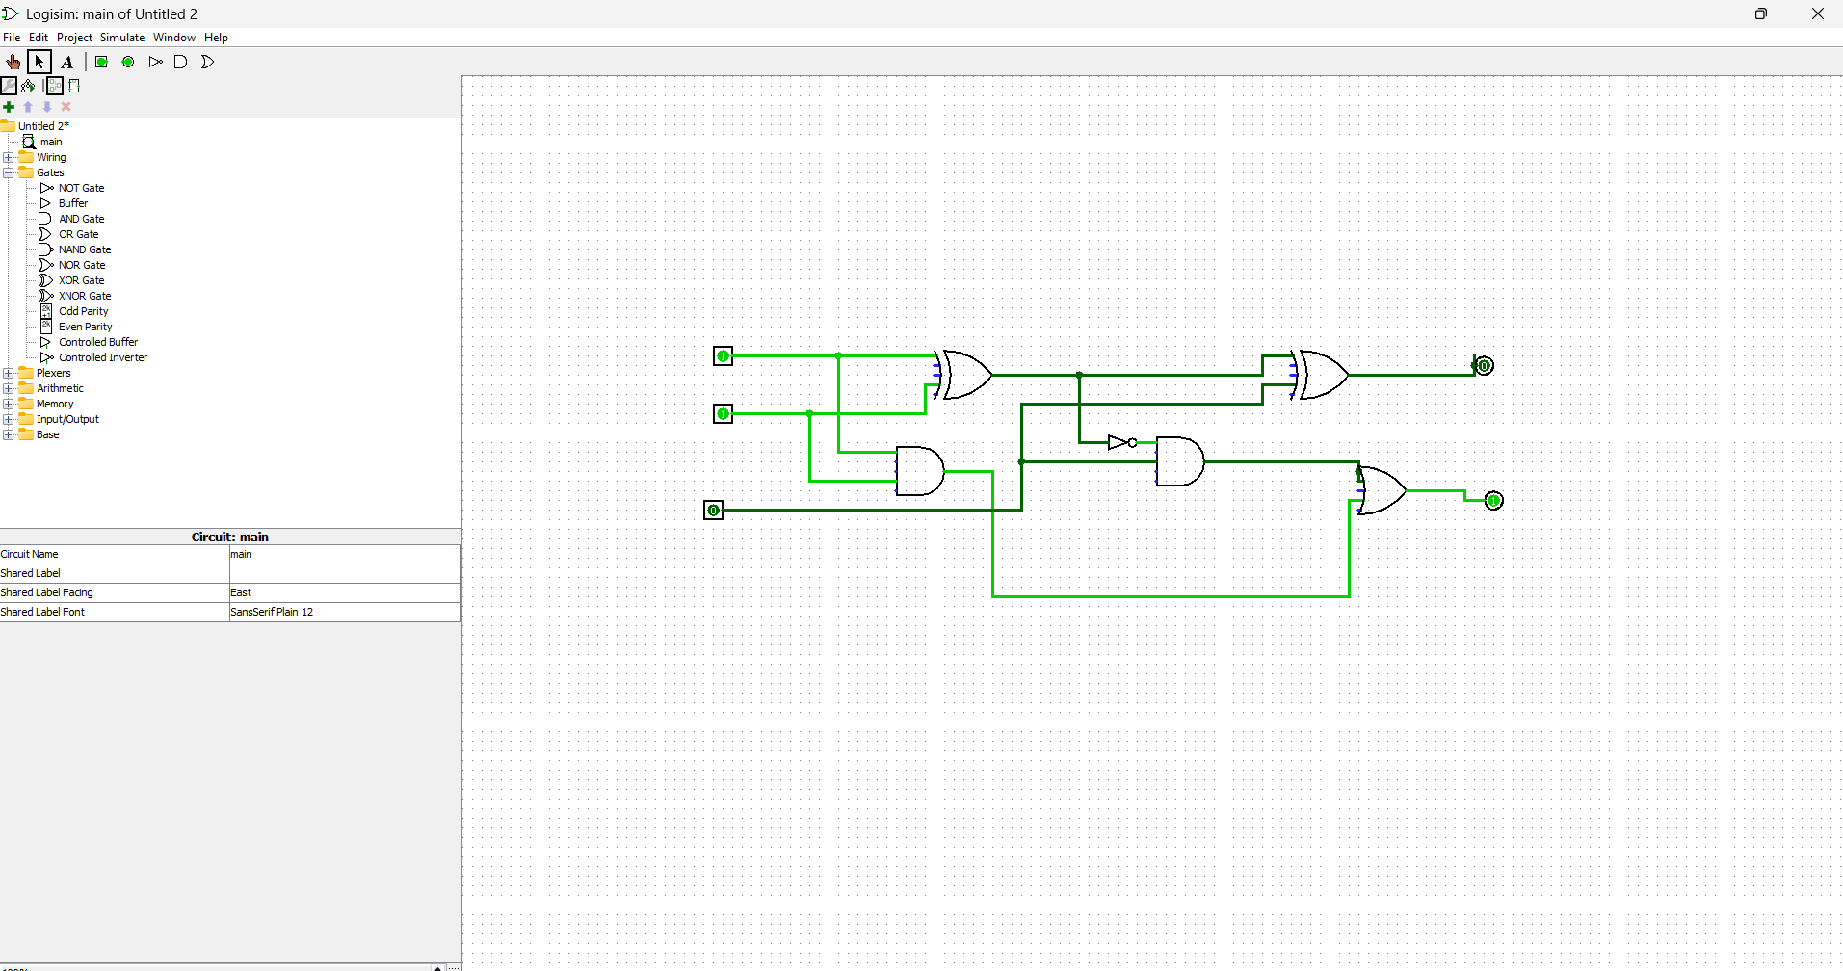

**RESULT:** Thus full subtractor has been designed and implemented successfully using logisim simulator.